**Assignment 18.2**

1. **Find out the top 10 destination people travel the most.**

**Driver Class:**

**Set 2 jobs for Top10Destination**

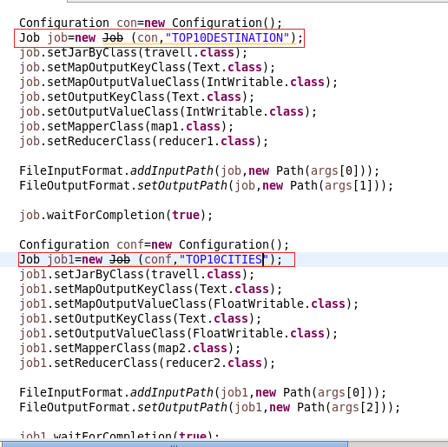

**Mapper1:**

**In mapper since top 10 Destination depend on no of people travelling a count of people were made from adult to infants and destination is send as key and count as value**

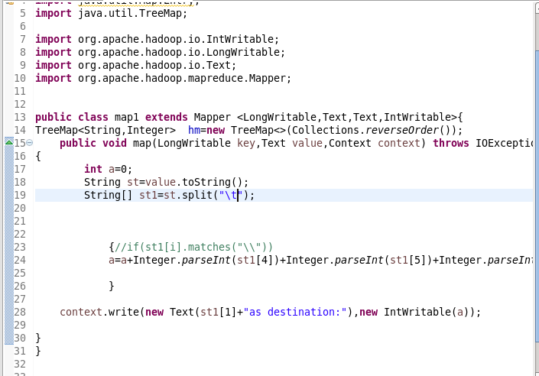

**Reducer:**

**Step1: overriding reduce method**

In reducer total count is found and in order to order by desc count is send as key to Tree map which will be sorted in descending order by collection.reverse order

**Step2: overriding cleanup method**

In clean up method since we want top 10 we will copy top 10 values into a new Tree map and the value will be written

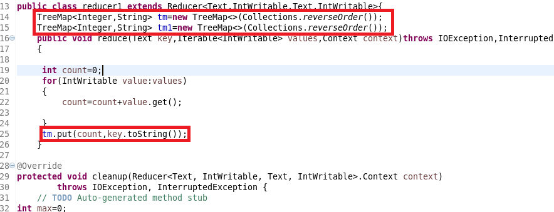

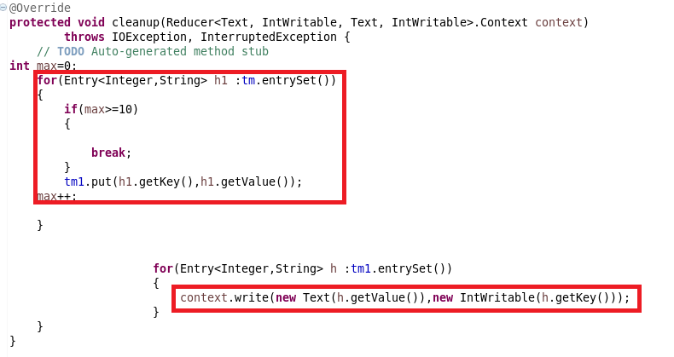

**Output 1:**

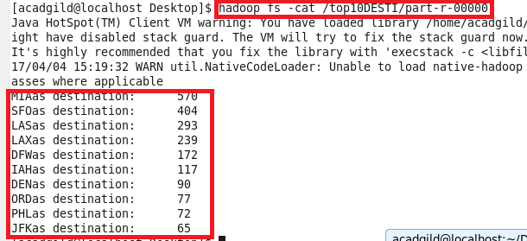

1. **Find out the top 10 cities that generate high airline revenues for travel, so that the site can concentrate on offering discount on booking, to those cities to attract more bookings.**

**Mapper2**

We will check for airline travel and send city pair as key and price as value

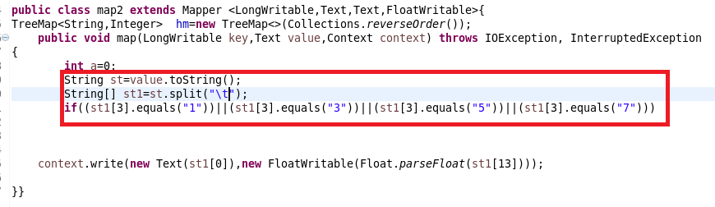

**Reducer2:**

**Step1:** overriding reduce method

In reducer total revenue is found and in order to order by desc revenue is send as key to Tree map which will be sorted in descending order by collection.reverse order

**Step2: overriding cleanup method**

In clean up method since we want top 10 we will copy top 10 values into a new Tree map and the value will be written

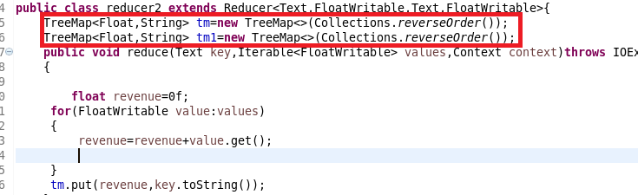

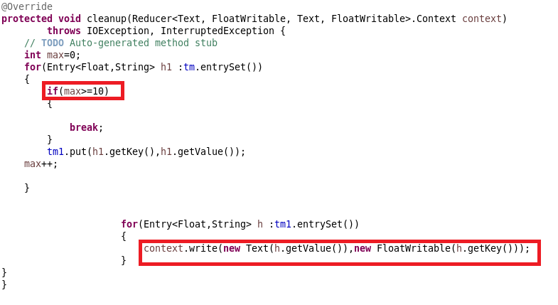

**Running JAR:**

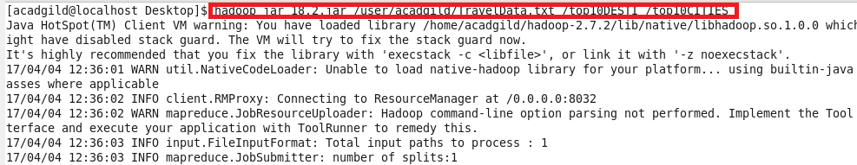

**Output 2:**

